**What the idea for the project is**

My previous project “Mi-In-Do” needs to be developed. It’s currently a 3 channel screen video installation. However, the original attempt was a 360 animation with VR installation. So I’d like to complete my original methodological attempt:

***Mi-In-Do* is a socially critical 360-degree animation and video performance of Orientalist paintings.**

Mi-In-Do is about the hidden culture of the lives of women and other non-normative groups as depicted in Asian Folk Arts during the Joseon dynasty. This piece is critical of the restrictive hierarchical culture of Confucianism which continues to fuel social pressures in Asia today. I use the motifs of Yin-Yang and the five elements, exaggerated by metaphor, to highlight the trauma caused by this system.

Within the animation, the viewer will play the role of a peeping tom, a voyeurist who must hide behind stones in order to watch the puppet-like 2d animations of women extracted from the Orientalist paintings. By the end, the performer will have actually eaten these women in a fantastic cannibalistic ritual.

The consumption of these two-dimensional women will evolve so naturally out of the action, and be so aesthetically enjoyable for the player that they will find themselves tricked into taking pleasure in the overt disposability and powerlessness of these creatures, who, uncanny though they may be, are depictions of the way real women were perceived under Confucianism.

Mi-In-Do is an immersive video experience that uses absurdity and aesthetics to lure the viewer into a confrontation with the contradictions of Confucian values. By being made to feel uncomfortable, uneasy, and overwhelmed they are given the opportunity to question the assumptions underlying dominant societal structures.

**How it engages/challenges the things we have discussed in class so far?**

1. **Will VR exist in the future?**

10 years from now, will VR be common? Maybe there will be a new virtual form of Google? Or its holographic? Or digitized contact lenses? Or maybe brain chips will be pervasive, making VR obsolete. If VR will stop production, and is inevitable to fix, how can museums negotiate? As a creator of my work, how can I negotiate over the installation?

1. **If the Unity 3D game engine is not available in the future, what can a museum do?**

Should I get the document film- like the video sets just in case if this engine doesn’t work in the future? How can I preserve the game engine if the technology no longer exists?

**what is your plan for developing the project between now and the end of the quarter**

**February 9 - 30**: complete the visual, animation, sound

**March 1 - 13**: complete Unity- Oculus quest part, and then make documentation & instruction guide

**What questions/issues you have to help develop the project**

1. I couldn’t find a way to replace the Unity program or VR. I need help.
2. Will the adult content be allowed in the museum?

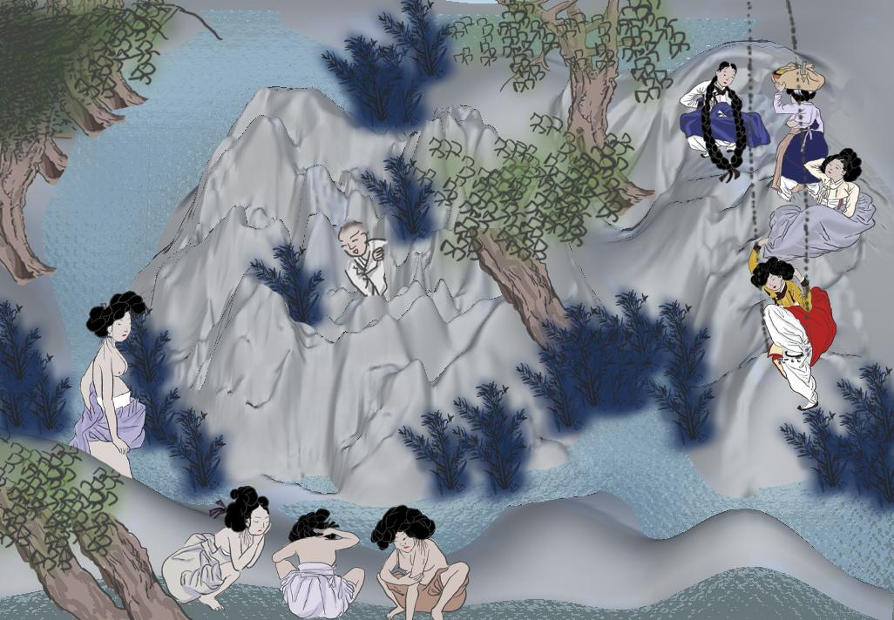

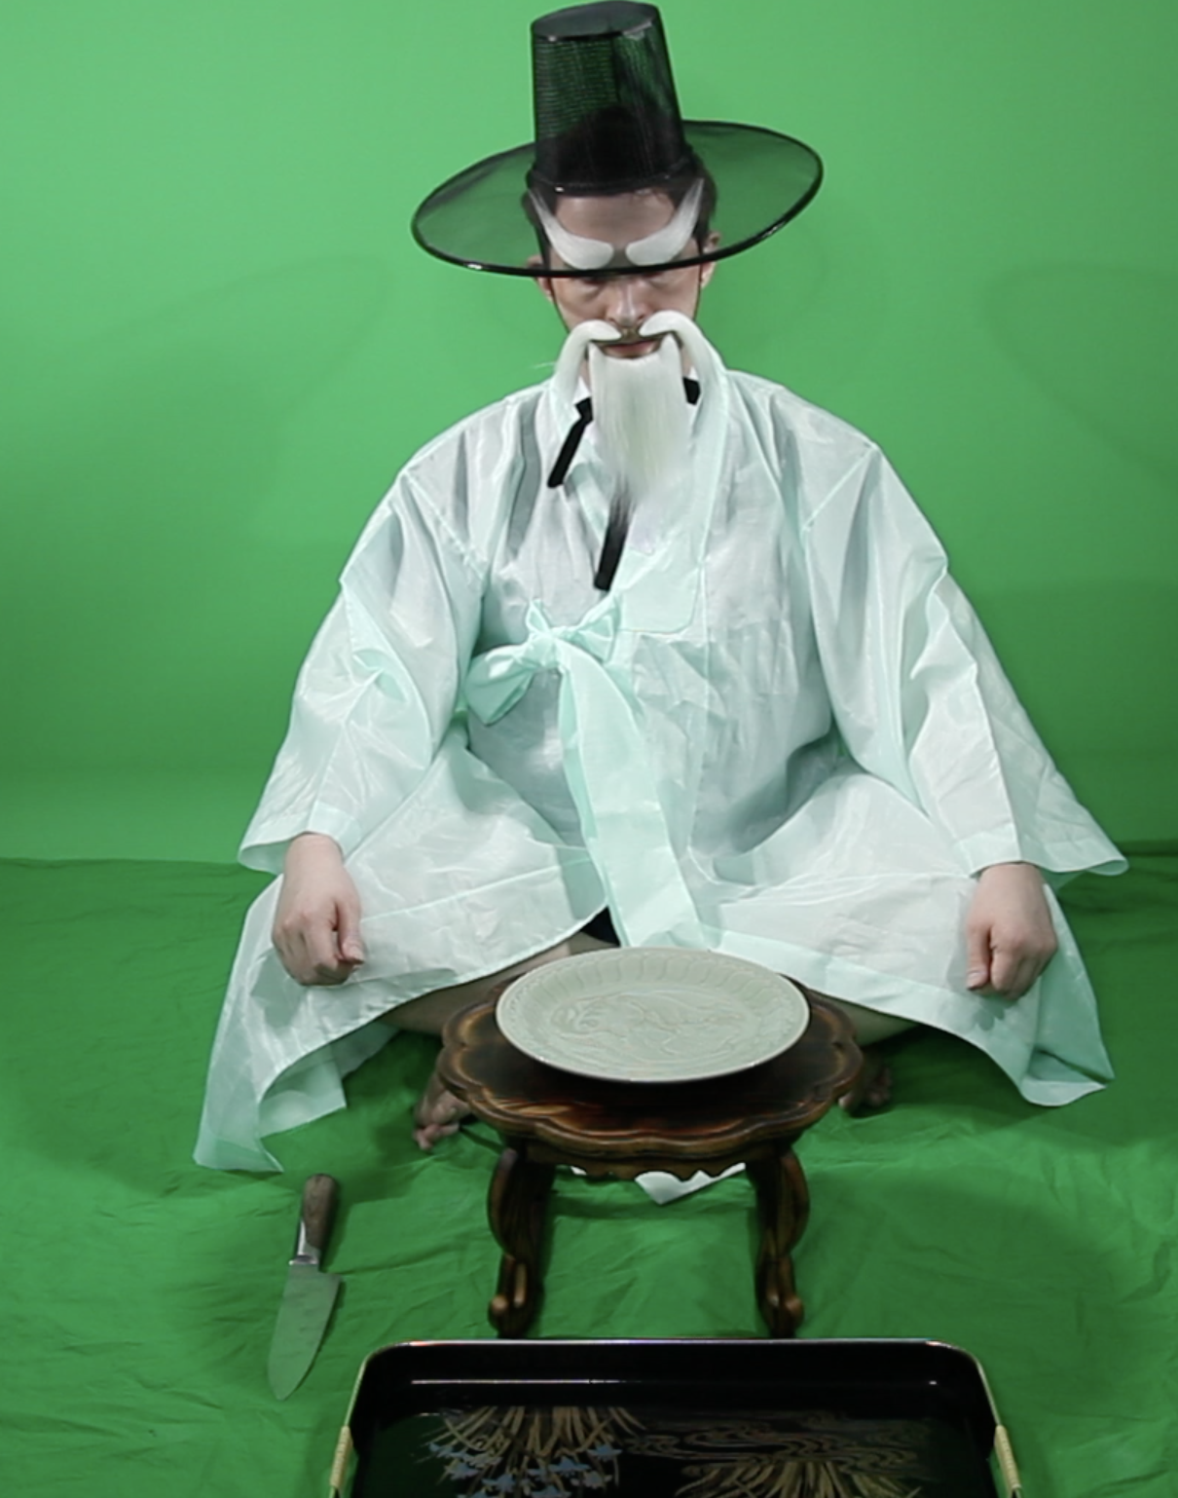

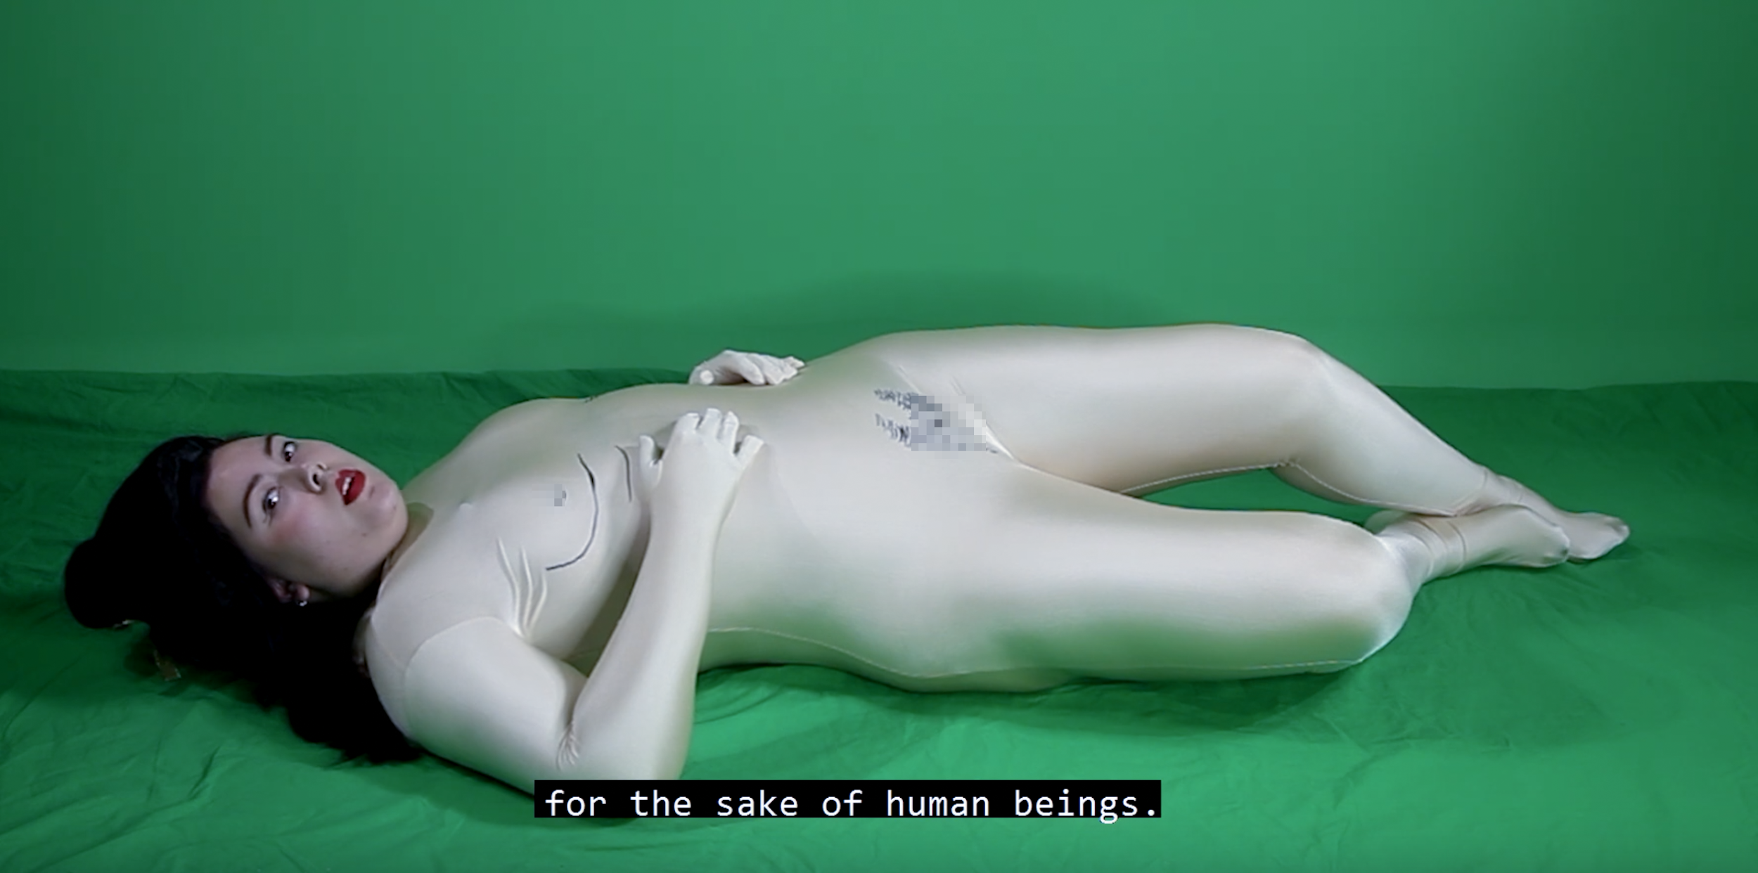

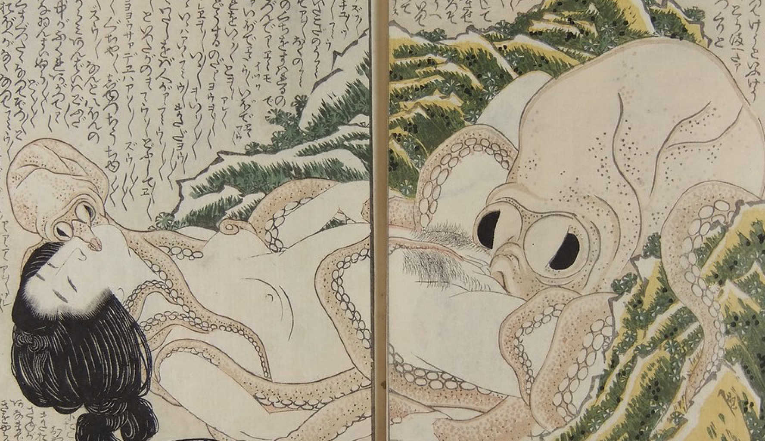

**Reference**

jess johnson:

<https://ocula.com/magazine/conversations/jess-johnson/>

Jess Johnson and Simon Ward:

<https://vimeo.com/139433350>

Nam June Paik’s work:

<http://www.koreaherald.com/view.php?ud=20190911000701>